**Statistical analysis to see the change in strength of wrist Surya Namaskar**

**Index**

|  |  |  |  |
| --- | --- | --- | --- |
| Sr.No. | | Topic | Page No. |
| 1) | | **Control Group** | **2** |
|  | **1.1** | **Data description** | **2** |
| 2) | | **Experimental Group (Right wrist)** | **4** |
|  | **2.1** | **Data description for right wrist** | **4** |
|  | **2.2** | **Before and after strength in right wrist :** | **7** |
|  | **2.3** | **Individual difference in strength of right wrist before and after** | **8** |
|  | **2.4** | **Hypothesis testing of Before and After strength of right wrist** | **9** |
|  | **2.5** | **Comparing the mean strength of control and experimental group of right wrist** | **10** |
| 3) | | **Experimental Group (Right wrist)** | **11** |
|  | **3.1** | **Data description for right wrist** | **11** |
|  | **3.2** | **Before and after strength in left wrist** | **13** |
|  | **3.3** | **Individual difference in strength of left wrist before and after** | **14** |
|  | **3.4** | **Hypothesis testing of Before and After strength of left wrist** | **15** |
|  | **3.5** | **Comparing the mean strength of control and experimental group of left wrist** | **16** |

**1 ) Control Group**

Simple Statistical analysis to control group :

* 1. **Data description :**

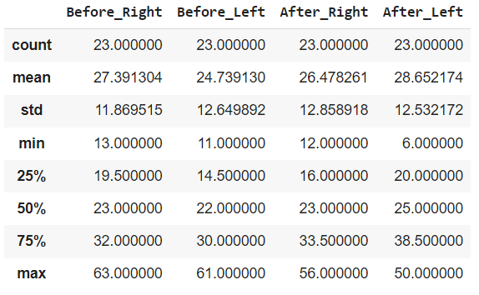

Conclusion :

1. The mean strength in right and left wrist of control group is seen to see same

From below graph we can see it.

1. The standard deviation of right and left wrist is same there is no change in that so we can say that before and after strength of students are same.
2. The minimum strength of right wrist before experiment was 13 and after was 12 and The minimum strength left wrist before experiment was 12 and after was 6 so there is no any changes seen in strength of right wrist.
3. The maximum strength of right wrist before experiment was 63 and after was 56 and The minimum strength left wrist before experiment was 61 and after was 50 so maximum strength decreasing.
4. From above description it is seen that 50% percentile for right and left wrist a almost 23 units.Which is constant for before and after.

It can be seen from box plot.

**2) Experimental Group(Right Wrist)**

**2.1) Data description for right wrist :**

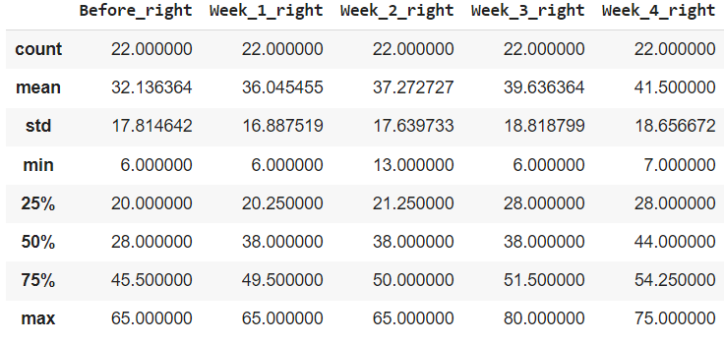

Conclusion :

1 ) The mean strength of right wrist is gradually increasing as the week days increase. We can say that there is effect of Suraya Namaskar on strength of right wrist.

From below bar plot we can see the gradual increase in mean.

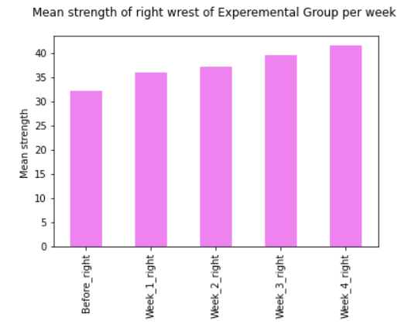

2 ) Before Suraya Namaskar 50% of students have right wrist straight of 28 units after 4 week is about 44 units. Box plot give the clear proof of it.

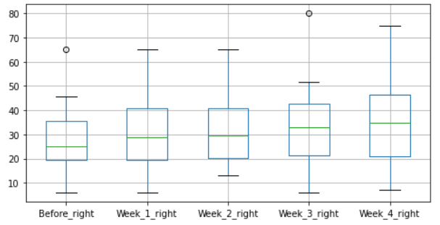

**2.2) Before and after strength in right wrist :**

Before Surya Namaskar After Surya Namaskar

|  |  |
| --- | --- |
| **Class of strength** | **Percentage** |
| 0-10 | 9.09% |
| 11--20 | 27.27% |
| 21-30 | 22.73% |
| 31-40 | 13.64% |
| 41-50 | 13.64% |
| 51-60 | 0.00% |
| 61-70 | 13.64% |

|  |  |
| --- | --- |
| **Class of strength** | **Percentage** |
| 0-10 | 4.55% |
| 11--20 | 13.64% |
| 21-30 | 13.64% |
| 31-40 | 18.18% |
| 41-50 | 18.18% |
| 51-60 | 13.64% |
| 61-70 | 13.64% |

**Conclusion :**

From the above frequency distribution it is seen that % of students that had increase in strength are above 30 units

For class 0 – 10 , 11 – 20 , 21-30 there is decrease in strength percentage of students and for class 31-40,41-50,51-60 there is increase in strength percentage of students. Which clearly indicates that there is increase in strength of right wrist after Surya Namaskar.

Below graph shows the change percentage of right wrist before and after Surya Namskar.

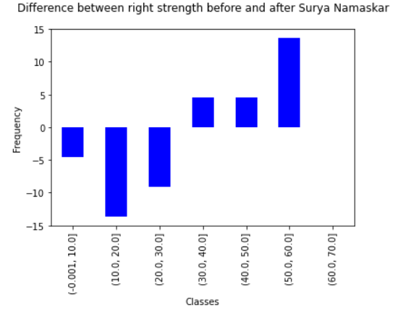

**2.3) Individual difference in strength of right wrist before and after :**

It is found that 2 students have found negative effect in strength 2 students have found no any effect and 18 (81%)students have found positive effect in strength of right wrist after Surya Namaskar.

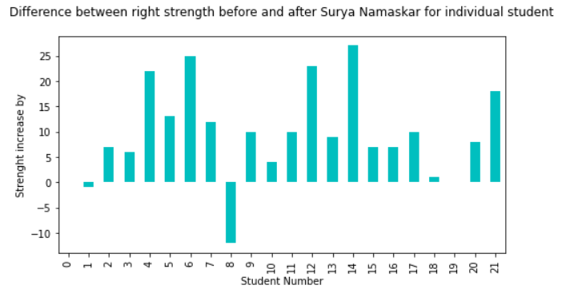

Student number 1 and 8 have negative effect while student number 0 and 19 have no any effect in strength.

**Hypothesis testing :**

Now our aim is to test is there any significant difference between strength of right wrist

**2.4 )Before and After strength of right wrist:**

**Hypothesis**

**Null hypothesis (Ho)** : Difference between after and before strength is greater than 0 .

There is increment in strength of right wrist after Surya Namaskar

**Alternative hypothesis (H1)** : Difference between after and before strength is less than 0 .

There is no any increment in strength of right wrist after Surya Namaskar.

Data is normal distributed (Shapiro-Wilk normality test) so we can perform paired t test :

**Out Put of paired t- test :**

Paired t-test

data: ar and br

t = 4.6603, df = 21, p-value = 0.9999

**Decision Rule :**

If P-value > 0.05 then we fail reject Ho other wise we accept H1.

**Conclusion :** Her P value is greater than 0.05 so we can conclude that there is increment in strength of right wrist after Surya Namaskar.

**2.5) Comparing the mean strength of control and experimental group of right wrist:**

**Null hypothesis (Ho)** : The mean strength of experimental group is greater than control group for right wrist.

**Alternative hypothesis (H1)** : : The mean strength of experimental group is less than control group for right wrist.

**Out Put of t- test :**

data: x1 and y2

t = 3.1315, df = 37.107, p-value = 0.9983

**Decision Rule :**

If P-value > 0.05 then we fail reject Ho other wise we accept H1.

**Conclusion :** Her P value is greater than 0.05 so we can conclude that The mean strength of experimental group is greater than control group for right wrist.

**3) Experimental Group(left Wrist)**

**3.1) Data description for left wrist :**

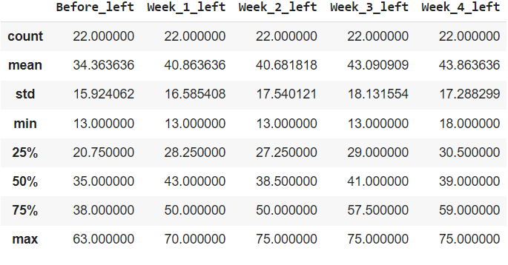

Conclusion :

1 ) The mean strength of left wrist is gradually increasing as the week days increase. There is on and average 9 units increase in strength We can say that there is effect of Suraya Namaskar on strength of right wrist.

From below bar plot we can see the gradual increase in mean.

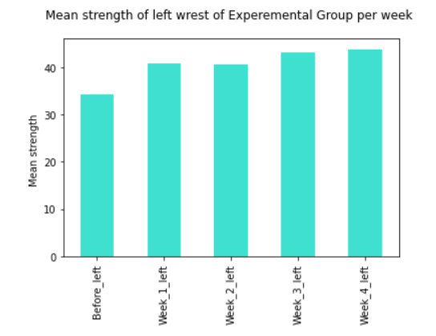

2) Before Suraya Namaskar 50% of students have right wrist straight of 35 units after 4 week is about 49 units. Box plot give the clear proof of it.

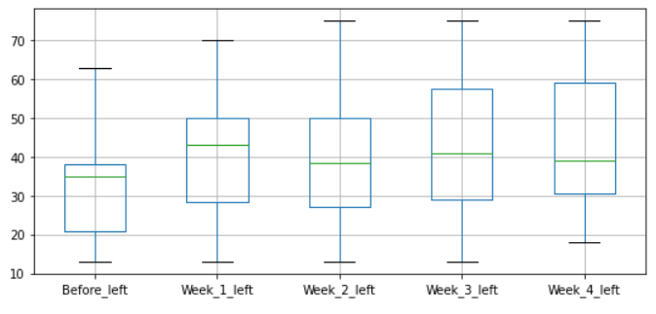

**3.2) Before and after strength in left wrist :**

Before Surya Namaskar After Surya Namaskar

|  |  |
| --- | --- |
| **Class of strength** | **Percentage** |
| 0-10 | 0.00% |
| 11--20 | 27.27% |
| 21-30 | 18.18% |
| 31-40 | 31.82% |
| 41-50 | 0.00% |
| 51-60 | 9.09% |
| 61-70 | 13.64% |

|  |  |
| --- | --- |
| **Class of strength** | **Percentage** |
| 0-10 | 0.00% |
| 11--20 | 13.64% |
| 21-30 | 13.64% |
| 31-40 | 27.27% |
| 41-50 | 13.64% |
| 51-60 | 9.09% |
| 61-70 | 18.18% |

**Conclusion:**

From the above frequency distribution it is seen that % of students that had increase in strength above are 30 units

For class 0 – 10 , 11 – 20 , 21-30 and 31-40 there is decrease in strength percentage of students and for class ,41-50,61-70 there is increase in strength percentage of students. Which clearly indicates that there is increase in strength of left wrist after Surya Namaskar.

Below graph shows the change percentage of right wrist before and after Surya Namskar.

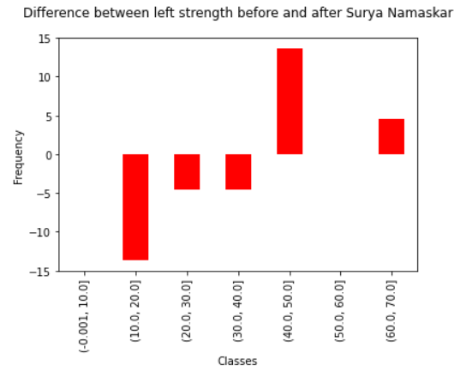

**3.3) Individual difference in strength of left wrist before and after :**

It is found that 4 students have found negative effect in strength and 18 (81%) students have found positive effect in strength of right wrist after Surya Namaskar.

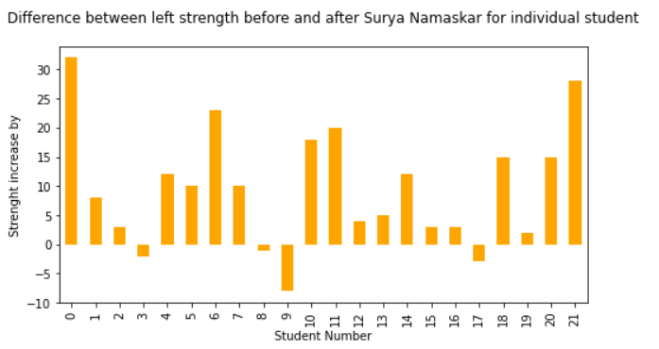

Student number 3,8,9 and 17 have negative effect while student number 0 and 19 have no any effect in strength.

**Hypothesis testing :**

Now our aim is to test is there any significant difference between strength of right wrist

**3.4) Before and After strength of left wrist:**

**Hypothesis**

**Null hypothesis (Ho)** : Difference between after and before strength is greater than 0 .

There is increment in strength of left wrist after Surya Namaskar

**Alternative hypothesis (H1)** : Difference between after and before strength is less than 0 .

There is no any increment in strength of left wrist after Surya Namaskar.

Data is normal distributed (Shapiro-Wilk normality test) so we can perform paired t test :

**Out Put of paired t- test :**

Paired t-test

data: al and bl

t = 4.3265, df = 21, p-value = 0.9999

**Decision Rule :**

If P-value > 0.05 then we fail reject Ho other wise we accept H1.

**Conclusion :** Her P value is greater than 0.05 so we can conclude that there is increment in strength of left wrist after Surya Namaskar.

**3.5)Comparing the mean strength of control and experimental group of right wrist:**

**Null hypothesis (Ho)** : The mean strength of experimental group is greater than control group for left wrist.

**Alternative hypothesis (H1)** : : The mean strength of experimental group is less than control group for left wrist.

**Out Put of t- test :**

Welch Two Sample t-test

t = 3.3667, df = 38.203, p-value = 0.9991

**Decision Rule :**

If P-value > 0.05 then we fail reject Ho other wise we accept H1.

**Conclusion :** Her P value is greater than 0.05 so we can conclude that The mean strength of experimental group is greater than control group for left wrist.

Thank you